**Parkinson ARCare Car Park**

**JobNumber**

**Revision A**

**Car Park Maintenance Report**

**Service Performed: 12/07/2018**

*Document Version: Thursday, 4 October 2018*

# Site Information

|  |  |
| --- | --- |
| **Site Address** | 20 Bufalino St, Parkinson |
| **Site Name** | Parkinson ARCare Car Park |
| **Service Date** | 12/07/2018 |
| **Service Company** | Integrated Control and Automation |
| **Service Personnel** | P.Meha |

# Service Contact

|  |  |
| --- | --- |
| **Company** | Integrated Control and Automation |
| **ABN** | 80 528 804 569 |
| **Postal Address** | P.O. Box 1645 Carindale, QLD 4152 |
| **Telephone** | 07 3890 8112 |
| **Email** | office@integratedengineering.com.au |

# Aim

The aim of the work performed is provide safe and energy efficient (if used to control ventilation) CO control of the car park via the maintenance of the existing CO sensors.

# Objective

The aim will be achieved by inspecting and calibrating, where necessary, each individual CO sensor in the car park. Sensors which are reading incorrectly will be calibrated and any faulty sensors will be noted and building personnel notified.

# Procedure

If this was the first time the service had been performed for this site by Integrated, an initial survey as performed:

1. Familiarise ourselves with the floor plan and identify locations of the CO sensors and ventilation fan.
2. Record the sensor and fan identification and locations on a site plan.

Each individual sensor was then subjected to the following service procedure:

1. Visually inspect the external and internal sensor for any obvious signs of failure or damage.
2. Purge the sensor with an inert gas.
   1. While subjecting the sensor to the inert gas, the sensor output across the test terminals was recorded.
   2. If the output did not read 4mA, then the zero potentiometer was adjusted until 4mA was reached.
3. Subject the sensor to the test gas of known concentration. (100 ppm in this case)
   1. While subjecting the sensor to the test gas, the sensor output across the test terminals was recorded.
   2. If the output did not read the expected mA output, then the span potentiometer was adjusted until the correct mA output was reached.
4. Label the gas sensor housing stating calibration date, service person, and the next service due date.

The current on each ventilation fan was also measured and recorded to ensure even load on the phases, and to monitor performance of the fan motors.

# Test Equipment Details

## Inert Gas

|  |  |
| --- | --- |
| **Gas** | Air zero grade |
| **Concentration** | THC < 1ppm |
| **Expected Zero Readings** | 0V across the test terminals |

## Test Gas

|  |  |
| --- | --- |
| **Gas** | CO Gas in air or nitrogen |
| **Concentration** | 100ppm |
| **Expected Zero Readings** | 0V across the test terminals |

## Multimeter

|  |  |
| --- | --- |
| **Manufacturer** | Amprobe ACDC-3400 |
| **Serial No.** | 101202783 |

# Calibration Equation

The relationship between proper current output and gas centration is given by Equation 1, and seen in Figure 1:

Equation 1: I = f(C)

$$Current \left[mA\right]= \left(\frac{16*Concentration_{ppm}}{SensorRange_{ppm}}\right)+4→i.e\left(\frac{16*100}{150}\right)+4=14.66 mA$$

The current is to be measured across at resistor so the expect voltage range is 2-10 volts DC.

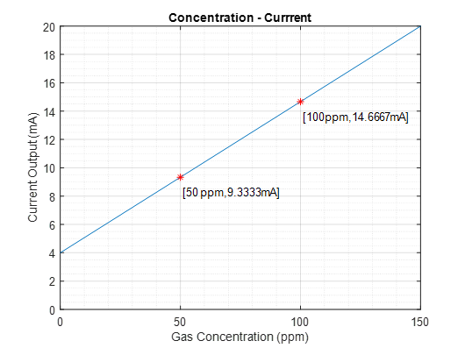

Figure 1

# Sensor Location

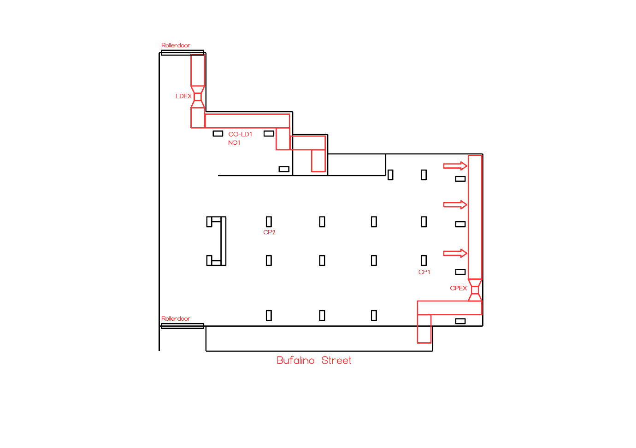

# Site Equipment Details

## Gas Sensor Calibration

|  |  |  |  |  |  |  |
| --- | --- | --- | --- | --- | --- | --- |
| **Last Service** | **Sensor ID** | **Zero Reading (VDC)** | | **Span Reading (VDC)** | | **Note** |
| **Original** | **Calibrated** | **Original** | **Calibrated** |
| June 2016 | CP1 | 2.015 | 2.002 | 7.74 | 7.34 | 🗸 |
| June 2016 | CP2 | 2.035 | 2.003 | 7.76 | 7.33 | 🗸 |
| June 2016 | CO-LD1 | 2.014 | 2.006 | 7.70 | 7.33 | 🗸 |
| June 2016 | NO1 | 2.010 | 2.003 | 2.008 | - | Replace |

## Ventilation Fan VSD Details

Set to manual, VSD read at 50Hz.

|  |  |  |  |
| --- | --- | --- | --- |
| **VSD** | **L1 (A)** | **L2 (A)** | **L3 (A)** |
| LDEX | 2.3 | 2.3 | 2.3 |
| CPEX | 4.2 | 4.1 | 4.1 |

# Findings

* All the CO sensors gave stable readings; however, calibrations were required for all CO sensors.
* The NO sensors gave incorrect readings and could not be recalibrated.
* The fan currents measured were equal and satisfactory.

# Recommendations

* **Replace sensor NO1 (ADT-23-1130-A-000002001).**
* Continue to retest sensors every 6 months. **To ensure safe and efficient ventilation a calibration is due on the @ 13 February 2018.**